**Assignment 3 Rationale**

**U3071480**

**Seunghun Lee**

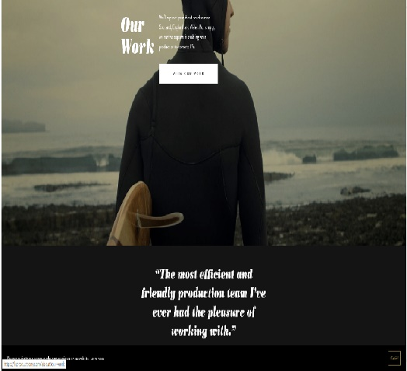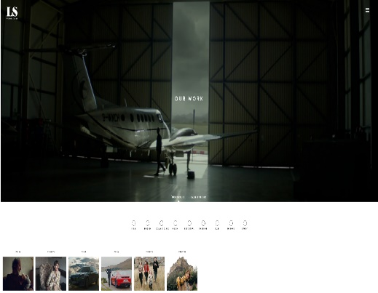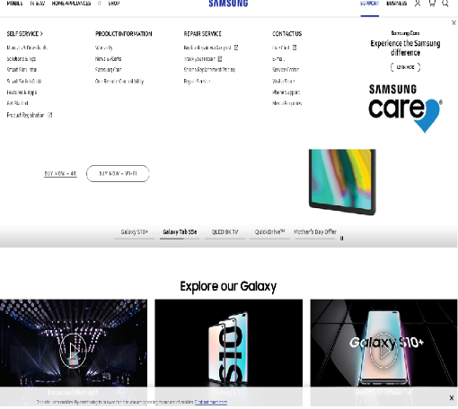

**Page 1 (Home)**

The pages of LS production and Samsung gave inspirations for Home of the project 3

The page includes many connected pages and each image has a box linking to other pages. Also, when people click the box, they are offered with many images and information of the companies. The page gives a ‘hamburger menu bar’, linked to various information such as SNS, contact and menus. The reason why I was inspired by the pages of LS production and Samsung is that the design and all the fonts, colours, logos and images used by them keeps things simplified. Lastly, the page has a dropdown menu for additional information.

Planning:

My project 3 would be structured into 4 pages; Intro page, Basic description of Norfolk page, History page, and a page dedicated to its Location. All the pages would be basically made to keep them simple and clear for readers. The first page would be made such as the inspirational first page. The intro page in the project would have 3 different images which are linked 3 pages respectively; introduction of Norfolk, Norfolk’s History, and Norfolk’s Location. Also, the page will have a footer, ‘made by Seung Hun Lee’. Introduction of Norfolk page will comprise of an image, a descriptive paragraph and a footer. The footer will be used to direct the user back to the intro page and back to the top of page. Next, the page on the History of Norfolk would be made similar to the previous page, because the two pages have similar data configuration. However, this page would be structured with a paragraph next to the main image. The last page is going to add a different style, such as a slide menu, because the page has many paragraphs, unlike the previous two pages. Also, the slide menu will be linking to each paragraph to provide an ease of access.

Design

The design of the pages will be based on “StyleSheet1”. Many colours have been used, such as #4D00FF;, blue; and #ffe6e6; the colours are extracted from “W3Schools”. The colours will be used for tags such as background, paragraphs and H1~H6. Each page includes different fonts, from Google fonts such as “Times New Roman”. Navigation would be used to link each pages and paragraphs. As the page used various fonts and colours, the readers would get clear information and feel comfortable when they access the pages and also, various CSS and tags would prevent readers to feel tedium. .

Layout: The project is structured into 4 pages, with intro page, introduction of Norfolk, History and Location. In the intro page, 4 layouts divide different sections; title, simple information, images for linking the other pages, and a footer. 3 images are merged into one, to offer the users with 3 simple circle icons. In the page of introduction of Norfolk, there are 4 layouts; title, slide of images, a paragraph and a footer. Next, in the page of History of Norfolk, it will have 4 layouts; the title, an image and one paragraph, other paragraphs and a footer. The reason why the paragraphs are divided is that the page has many sentences, and I thought it would be necessary to provide easier reading experience whilst making them less like ‘wall-of-text’. The last page is structured in 10 layouts; a dropdown menu, an image, the title, 6 paragraphs and a footer. 6 paragraphs are linked with the dropdown menu, to provide convenience in accessing information to the users. All the page would provide ‘footer’ for access other page such as home

* **Challenges**



In the first page of LS production, it has an animation that provides a brief introduction. It is a text-alternative for non-text content, and the structure is logical, because the animation helps visitors to understand more easily and quickly as an alternative for non-text content. Utilisation of an animation was very difficult, because although the use of an animation provides easy accessibility, there are limits of using only HTML and CSS instead of other professional video-editing tools. This project will use a slideshow as an alternative for an animation, because although it lacks expression in comparison to an animation, a slideshow has a good functionality when expressed as non-text. The other challenge is a dropdown menu and a hamburger menu. Each menu presents contents in a meaningful order and a logical structure, because when viewers click the menu, they can easily access other pages and more information. The dropdown menu is included in project 3 as an accessibility function, and the hamburger menu can be used in project 3 to simplify available options. However, due to my own limited experience and skillset in using HTML and CSS, I’ve had a lot of issues in completing the hamburger menu without any flaws.

* Accessibility Audit.

There are 3 pages to present my project results. The project provides a text-alternative for non-text contents, such as images, and also the pages are very logically structured with meaningful sequences. This is achieved as paragraphs, images and menus, which all have different colours and sizes, were made with one goal, easy-of-access. In the first page, the page mentions “not provide audio control”. In addition, there are many problems about keyboard, such as keyboard traps and options that can only be accessed by a keyboard input. The project does not use any contents that flashes more than three times per second, but the project uses a slideshow alternative flash function. In all the HTML, the page starts with the language of the page such as English. Secondly, ‘introduction of Norfolk’ have images slide for one of functions of accessibility audit because as used the function, viewers would get many information easier than just enumerate images. The third page has many paragraphs, in other words, if the page just provides only paragraphs, viewers could feel difficult to read all paragraphs so the page would use ‘three box tag’ for legibly. The last page has menu for accessible each paragraph with used tags ‘href’ and ‘menu bar’. In other words, the all pages focus on accessibility audit. All pages have further been checked for major code errors through W3C Validator

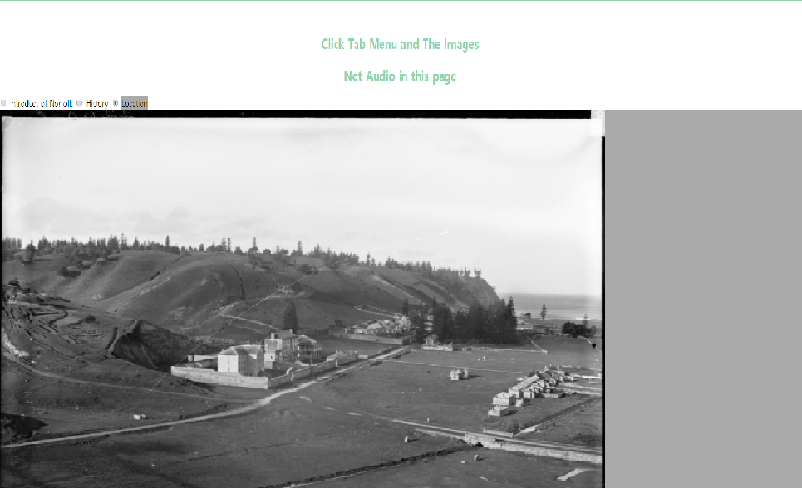

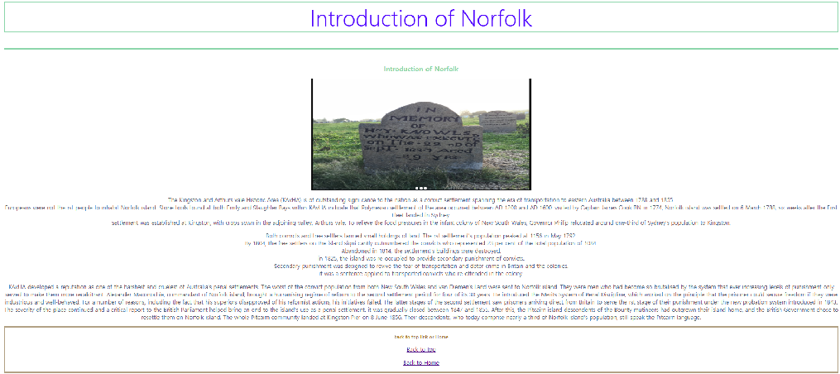

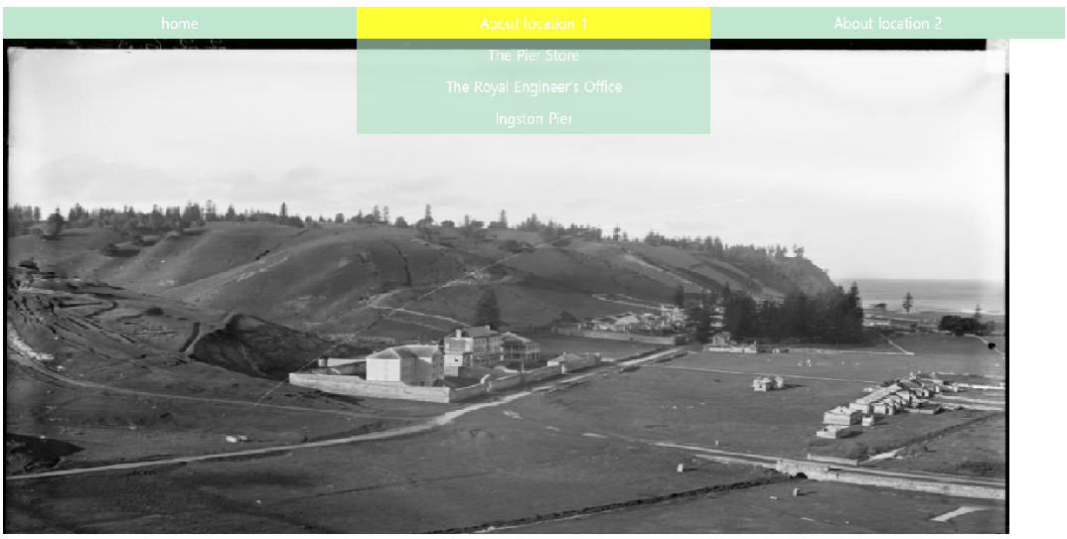

Resources

Google font (used change fonts)

HTML Cheat Sheet (used various tags)

Font Awesome (trying to make hamburger menu)

W3schools (used slideshow)

HTML Colour Picker (used change colours)

LS Product (linked the other page through image <article class=””><a href=”” class=”linke”></a>

Samsung Home page (<button type=”button” class=””> <Span class=”blind”></span>)

References

Digital.com. (2019). *HTML Cheat Sheet [Inc HTML5 Tags]*. [online] Available at: https://digital.com/tools/html-cheatsheet/ [Accessed 13 May 2019].

Fontawesome.com. (2019). *Font Awesome*. [online] Available at: https://fontawesome.com/icons/bars?style=solid [Accessed 13 May 2019].

LS Productions. (2019). *UK-wide Service Production Company*. [online] Available at: https://lsproductions.com/ [Accessed 13 May 2019].

Samsung au. (2019). *Samsung Australia*. [online] Available at: https://www.samsung.com/au/?cid=AU_2018__02_TXT_NA_NA_NA_samsung_NA_NA_NA_7789085785_NA&ef_id=CjwKCAjwiN_mBRBBEiwA9N-e_o9PH7kVl9aPEMCvAUxMET9VGJ-4SQj6CXH4qCJmfKK0j8BvQp499BoCZlcQAvD_BwE:G:s&gclid=CjwKCAjwiN_mBRBBEiwA9N-e_o9PH7kVl9aPEMCvAUxMET9VGJ-4SQj6CXH4qCJmfKK0j8BvQp499BoCZlcQAvD_BwE&gclsrc=aw.ds [Accessed 13 May 2019].